2.1 Done
2.1B How would you define ‘artificial intelligence'?//
A non living object that can store knowledge and use the knowledge to apply it in situations.
2.1C
1. Google assistance on a google home, this uses AI for recognizing language and finding a result that fits my question.
2. Using AI for looking at medical records or images it can make diagnosis that sometimes are more accurate than human diagnosis due to biases or human mistake.
3. A Swiss town near where I go every year uses an Radar together with a deep learning algorithm to detect if it is safe to cross a road or that there is danger of falling rocks(https://www.youtube.com/watch?v=o-oVXYkBwgw&t=46s)

2.2 to be made
2.2a Reading …
2.2B Strong and Weak AI
Strong AI can be refereed to being “consciousness” But it feels more like AGI(Artificial general intelligence). This strong/AGI AI can overcome a lot of obstacles and is not focused on solving one issue. Weak AI on the other hand or Narrow AI is weaker in the sense that it is made to do one task and wont be able to do anything else, for example an image recognition soft where that can see if there is a cat in an image, this Narrow AI wont be able to recognize anything else than a cat.
2.2C no
2.2D (Answer B in short)
What is the ‘Chinese room experiment'? Describe its procedure.
This experiment is when you put a non Chinese speaker in a room and give them a Chinese sentence and an “algorithm” or more easily a step by step guide what to do, if you see this than do that just like how a machine would execute code. Because it is just following instructions you could say that it isn't thinking. I also believe this is what happened when an AI in google called LAMBA was released to be sentient. It is more likely that this AI repeats information it has learned so if you where to ask it if it was not sentient the AI would answer that it isn't sentient. So the AI might be able to process language and give a response but it probably isn't able to make new ideas that are not yet in his database.
2.2FConnect the Post It notes (Fig 2.) to the relevant quadrant in the philosophy matrix (Fig 3.). For example, A = 1, 2, and B = 3, 4, 5 etc. Elaborate on your choices.
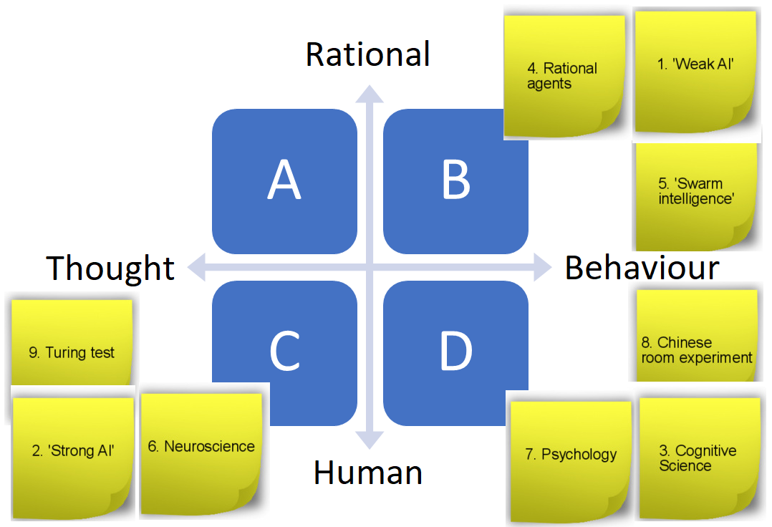

1.b because weak AI follows instructions(algorithm) and the behavior is predictable
2.C Strong AI can complete different tasks just like a human could and is able to produce his own thoughts based on his knowledge.
3.D This is looking at human behavior and how we interact with the world around us and how our brains make intelligence
4.B rational agents has it in his name, it makes discussions on already available information and follows a strict form of behavior like if this than that.
5.B I am not sure but I think swarming a problem and using a trail and error approach and survival of the fittest where the best performing subjects go on to a new generation.
6.C Neuroscience is trying to understand how the brain works and in turn how we remember and get new ideas from and it does this by looking at our physical brain and neurons and axons and everything related.
7.C Psychology is not looking at the biological reason why why do things but tries to explain them, why do we feel sad? And why do we like to do this or that.
8. B this test shows that when we follow a rational algorithm that we then can make desirable behavior.
9.C The turing test is a test where an AI is tested on his ability to fool a human. For the test to be a success the majority must think that the AI is an actual human. Fun fact the turing test doesn't take in what humans are being tested on. The highest percentage is that of Men in a sex chat bot situation.

2(3).2G
No I wont seeing how my knowledge that I based my answer on did not change or expend in a way that makes me change my mind

